**Materials: (Blue materials on Github)**

Macrocolony:

1x BeeGo Base (27x27 cm)

1x BeeGo Roof (27x27 cm)

8x BeeGo Straight Brick (7.5 cm)

4x BeeGo Straight Brick (4.5 cm)

4x BeeGo Corner Brick

4x BeeGo “Tacks”

1x BeeGo Wax Catcher

1x Reservoir

¼ lb Soy Wax

Aluminum Foil

9x Wicks

Microcolony:

1x Partitioned Microcolony (14 x 14 cm)

4x BeeGo “Tacks”

1x Partitioned Roof (14x14 cm)

1x Reservoir

1x KimWipe

1x Wick

10 mL 40% Sucrose Solution/4 bees

1 Gnocchi-sized ball of Pollen Dough (doughy mix of ground pollen & honey)/4 bees

1 Penny-sized ball of wax/4 bees

1 4x4 ARUCO Tag/Bee (printed using Silhouette and Cameo)

2 IR Light Chandeliers (requires 7 IR lights each)

6 Infrared Lights

1 Falcon Tube/3 Bees

1 Ice Bucket (with ice...duh)

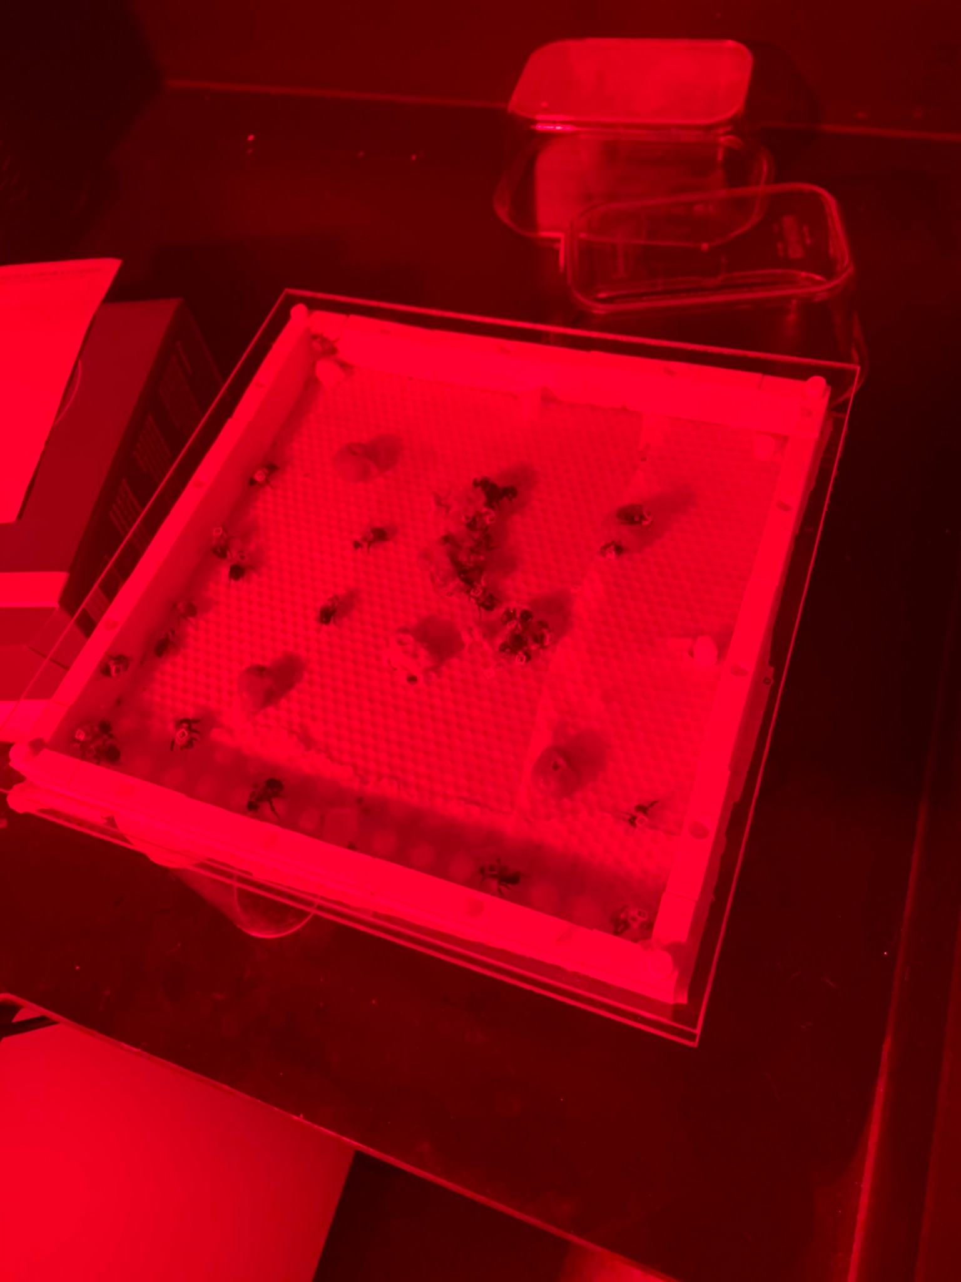

**1a. Assemble the Macrocolony**

* 1. Take one BeeGo Base, and cover all holes with aluminum foil
  2. Insert BeeGo Blocks in the above pattern (25.5 cm x 25.5 cm). Puncture the aluminum foil with the blocks (it helps to flatten the foil with your hands very lightly before inserting the blocks). Tape the connections between the block and aluminum foil to prevent the wax from leaking.
  3. Cover the aluminum foil with the “wax-catcher” so it is flush with one corner of the base. There should be approximately a 5x5 cm region on the opposite corner which isn’t covered by the acrylic wax catcher.
  4. Melt soy wax and fill the colony 2 mm thick with melted soy wax. Let solidify.
     1. *Note*: beeswax will disrupt the chemical communication in the hive. Avoid using it.
  5. Replace the two 7.5 cm BeeBlocks with a vented Bee Block
     1. *Note:* wax will melt through those blocks if you don’t add them beforehand!
  6. Use “tacks” to attach acrylic roof of the macrocolony.
  7. Fill the reservoir up to 3 mm thick with 40% sucrose solution
  8. Use a razor to cut the uncovered 5x5 cm corner out. Use the smallest lego piece to puncture 9 holes in that corner. Fill those holes with wicks, and place over the reservoir. Put over another reservoir on the other corner as a balance.
  9. Add wax & pollen dough to the center of the colony.

**1b. Assemble the Microcolony**

1. Take one microcolony
2. Cover the microcolony with a kimwipe. Add wax & pollen dough kitty corner to the hole
3. Fill the reservoir up to 3 mm thick with 40% sucrose solution
4. Fill hole with a wick, and connect to macrocolony.
5. **Tagging bees**

*Note*: for every step here, do under red light. Bees struggle ti see red light, and it will make the ordeal less stressful for them. For long term imaging, try to use infrared light instead.

1. Obtain untagged bees in test tubes (1-4 bees per tube)
   1. To get individual bees, remove three of the four “tacks” and slide the lid to expose one corner. Slide a piece of paper between the plexiglass top and walls of the corner diagonal from the remaining tack. This will ensure only one section of the base is open for bees to escape.
   2. Using a Falcon tube, capture individual bee. Place the tube next to or over the target bee. Once a bee has moved into the tube, pick up, place the lid and close carefully. Slide the base closed carefully ensuring no bees have escaped or have climbed the walls
   3. *Note*: You can put multiple bees in the same falcon tube, but it’s easier when the other bees are chilled.
2. Chill bees in test tubes on ice for about 15 minutes or until immobile
   1. *Note:* cover falcon tubes completely with ice.
3. Take one test tube and place immobile bees wings-up on solid surface
4. Using insect pins, dab a small amount of super glue on each bee’s back between head and wings
5. Using another insect pin, stab tag and place carefully on bee’s back where glue was placed.
   1. *Note*: here it is helpful to have three pins. One for super glue, one for the tag and a third to help you maneuver and press down your tag. After using the upright pin to place the tag onto the super glue, using the long side of the third pin press the tag down into the super glue to make sure it’s properly adhered.
   2. *Note:* Make sure to orient the tag so that the dot is facing forward from the bees perspective.
6. Once all bees are tagged, allow to rest on ice for a few minutes to allow glue to set.
   1. *Note:* Be careful that the bees cannot get wet!
7. Put bees back in BeeGo Base with their bellies down to make sure that excess glue does not stick to the base.
8. Wait for bees to wake up (a few minutes) to ensure tags remain and no individual bee is stuck to walls or base.
9. **Colony Maintenance:**
   1. Bees should have continuous access to bee bread and 40% sucrose solution
   2. *Bee Bread:* made in bulk. A mixture of raw honey and bee pollen to form a dough-like consistency. Small ball units of bee bread are frozen to kept fresh and can be placed directly into macrocolony when needed.
   3. *Sucrose Solution:*
      1. Mix 40 grams of sugar with 60 grams of water in a Falcon tube & shake until sugar is completely dissolved
      2. Fill reservoir with the sucrose solution.
   4. Every day, replace vials of sugar water and check quantity of pollen and wax.
10. **Filming**
    1. We will be filming on the 5th and 7th day of the microcolony, and on the 1st through 5th days of the macrocolonies.
       1. The rationale behind this is that microcolonies need time for a dominance hierarchy to develop (Amsalem et. al) while our macrocolonies should have a pre-existing colony.
    2. On the day of filming, move bees to film studio at 10:00 am.
       1. Do this in their respective containers.
       2. *Note:* Timing matters here! Bees, like humans, have strong circadian rhythms -- we do not want a batch effect because some bees are being filmed bright and early while others are being filmed late.
    3. Put macros on top of heating pad, and micros on top of a small tarp to catch sugar water (shouldn’t be necessary with new reservoirs)
    4. Adjust settings
       1. General parameters: FR: 20 frames/s, Exposure: 10000 us, Gain: 5 dB
    5. Begin filming for 24 hours on labcams.
    6. At 11:00 am, remove colony.
       1. If doing RNA-seq, move each bee to an eppendorf, label the tube with the tag number and eclosion date, and flash freeze the bees in dry ice. Put the frozen bee in the appropriate box of the -80 freezer.
       2. Otherwise, put in the hallway -80 freezer for 24-48 hours, then throw out the bees.
       3. *Note:* If you need to both film & remove a colony, try to use the one hour flex time to transfer between the two. If space is a concern, you can remove the old colony a few minutes early and it won’t be a huge problem.

**Current Goals:**

|  |  |  |
| --- | --- | --- |
| Main Researchers | Question | Current Materials Using Above Protocol |
| Tatum’s Project | Influence & Aggression in Microcolonies | 4 Microcolonies (all from ST) |
| Alexis’ Project | Titrating Aggession Into Microcolonies | 24 Microcolonies: 8 with no JH bees, 8 with 1 JH bee, 8 with 2 JH bees (all from ST) |
| Dee’s Project | Developing a Social Network of Macrocolonies | 3 Macrocolonies: 2 older ones (from HP), one newer one (from ST) |